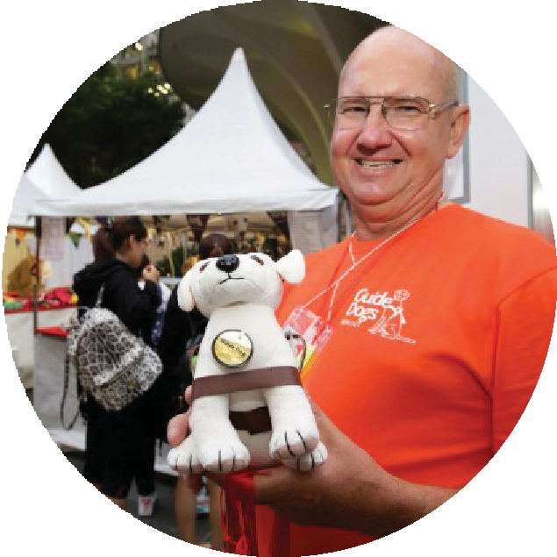
On behalf of Guide Dogs NSW/ACT (Guide Dogs) (us, we, or our) we would like to thank
Your
responsibilities
as a fundraiser
Terms & Conditions
you for your interest in raising funds to help us to continue our goal of enhancing the mobility of people with impaired vision. Guide Dogs appreciates all the support it receives from corporations / organisations and the greater community.

These terms and conditions apply to organisations, groups and individuals (you or your) that are planning to fund raise on behalf of Guide Dogs and by submitting your Application for Authority to Fundraise (Application) with Guide Dogs, you agree to comply with and to be bound by these terms and conditions. If you have any questions, please call the Fundraising Coordinator on
(02) 9412 9325 who will be more than happy to assist you.

- If your Application is approved, Guide Dogs will:
- issue you with a Letter of Authority to fundraise specific to your approved event or activity (Letter of Authority); and
- allocate an Authority to Fundraise number to you. To assist Guide Dogs in processing all queries quickly, please quote the event number in all correspondence with us.

- You must be registered with us and have received our Letter of Authority before you start any fundraising. You may fundraise during the approved dates only, and only for the approved event or activity indicated in your Letter of Authority.

- If you wish to extend, or change any aspect of your fundraising event or activity you will need to seek additional approval from us. Guide Dogs may issue a new Letter of Authority or revoke approval of the fundraising activity.
- You must ensure that the event or activity is run in accordance with relevant charities legislation and or regulations in the state or territory which the fundraising activity is being held, and you must obtain any permits, authorities, licences
and insurances needed. For example, permits are required by councils and shopping centres for events in their area/on their premises and State government permits may also be required for the conduct of raffles or prize draws. Different states have their own legislation, which should be checked beforehand. If you require guidance in
this area, please phone Guide Dogs. Copies of any permits must be sent to Guide Dogs.

- You are responsible for ensuring the safety of the event, volunteers and personnel including organising appropriate public liability insurance and providing first aid services if required. Guide Dogs’ insurance policy does not cover events conducted by external organisations/individuals.

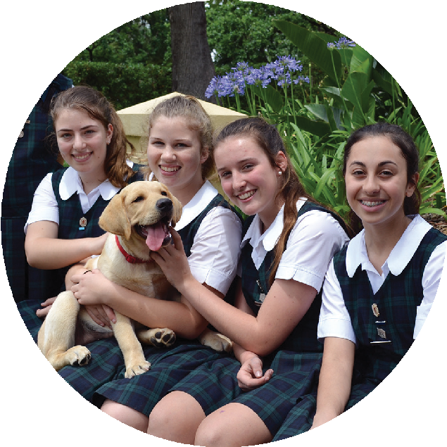
- Any use or our logo, text, images, name or any other branding must first be approved by us.

Your
responsibilities
as a fundraiser

- All publicity in reference to the fundraising event/activity should clearly state that the event/ activity is being organised by you. All promotional material must be worded in such a way as to make it clear that Guide Dogs is either the only beneficiary, or is one of a number of charities benefiting from the event.

- You must make it clear in any dealings with the public, donors, sponsors and supporters that you are not our agent or representative but are acting on your own behalf to raise money for Guide Dogs.

- You hold all funds raised from the public on behalf of Guide Dogs until the fundraising event/ activity is completed and you must ensure that the funds are kept in a secure place, full records of income and expenses are made and that these are sent to Guide Dogs within seven days of the fundraising event/activitytaking place.

- All costs and debts associated with your fundraising activity or event are your responsibility and we will not be liable for any financial loss suffered by you or those involved.

- You acknowledge that only Guide Dogs is authorised to allocate donated funds within Guide Dogs.

- You must not approach the general public with door-to-door, street or telephone collections as part of the fundraising activity/event.

- If you are planning to involve children in your fundraising activity you will be required to comply with further guidelines from Guide Dogs. This is because some states have special regulations that apply when children participate in an appeal. Different rules apply for children of different ages.

- You must disclose any prior or current criminal convictions. Although these will not necessarily stop you from being able to support Guide Dogs, they will be taken into account in agreeing to your suitability as an organiser.

- The organiser agrees to release Guide Dogs to the fullest extent permissible under law for all claims and demands of any kind associated with the fundraising activity/ event, and to indemnify Guide Dogs for all liability or costs that may arise in respect to any damage, loss or injury occurring to any person in any way associated with the fundraising activity/event.

- We may at any time without the need to give any reasons, withdraw your approval to fundraise by notification in writing.

To enable Guide Dogs NSW/ACT to keep in touch with our supporters and to comply with our legal obligations, keep a register of fundraising events. The following document together with any supplementary information must be completed and returned to the Fundraising Co-ordinator at Guide Dogs NSW/ACT via email, fax or post, before an Authority to Fundraise can be issued.

Application for authority to fundraise

Att: Kim O'Meally
Guide Dogs NSW/ACT
PO Box 1965, North Sydney NSW 2059
P (02) 9412 9450 E komeally@guidedogs.com.au
Title First name Last name
Company/Organisation name (if applicable)
Position within company (if applicable)
Address
Suburb | State | Postcode
Home phone | Mobile | D.O.B
Email
Name of proposed event
Description of fundraising event/activity
Event location/address |  | Start date End date

Have you ever been convicted of a crime in Australia? If yes, please explain
Yes No

I confirm that I do not have any health or medical conditions that would affect my ability to carry out the tasks required by the role?
I agree this event will result in a donation of % of net profits (Please state percentage)

Please state other beneficiaries from this event (if applicable) Amount estimated to be donated to Guide Dogs: $
I have read the terms and conditions and agree to comply with any legal requirements of fundraising and with the Guide Dogs conditions for fundraising. I understand my obligations with regards to sending the proceeds raised to Guide Dogs within 7 days.

Signature
For our latest privacy policy visit www.guidedogs.com.au/privacy-policy
Guide Dogs NSW / ACT will investigate any person who is alleged to be using its name to deceive the public to make personal profit, or using its name in an unauthorised manner. Guide Dogs reserves the right to refuse or withdraw permission to fundraise on its behalf. Guide Dogs NSW/ACT ABN 52 000 399 744

